Clearing of Cookies in MOZILLA FIREFOX
Action: Login to Oracle Financials via “Harvard Key”.
After authenticating via Harvard Key IF YOU GET AN ERROR as shown in screenshot below then please follow the rest of the screenshots to delete cookies in Mozilla Firefox.
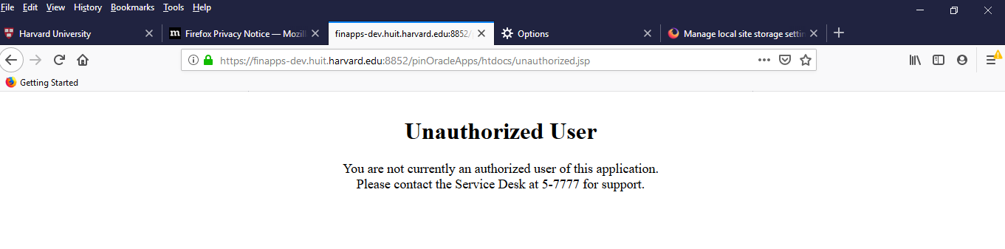

Steps to Delete Cookies in Firefox
Screen 1: Trying to open Firefox settings
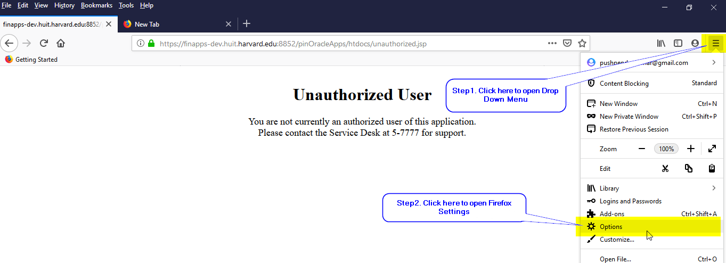

Screen 2: Opening “Cookies and Site Data” section in settings
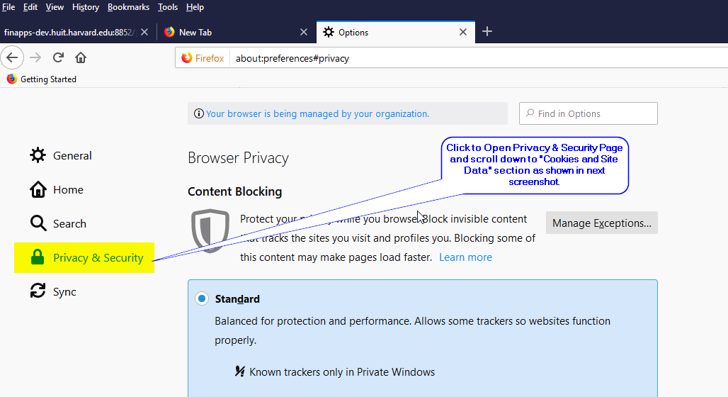
Screen 3: Opening window to clear cookies
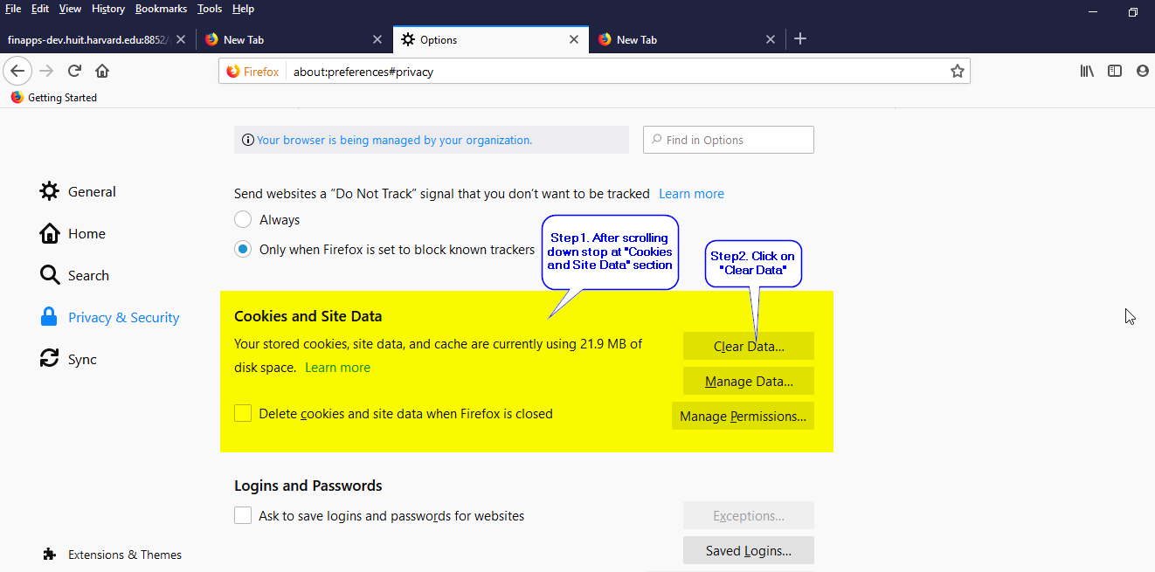

Screen 4: Selecting Cookies and Site Data option
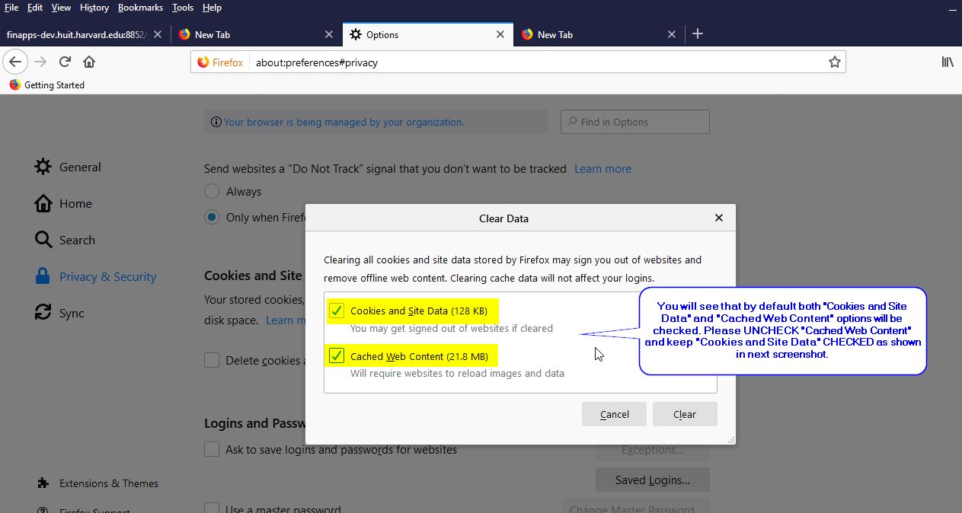
Screen 5: Final Step “Deleting Cookies”
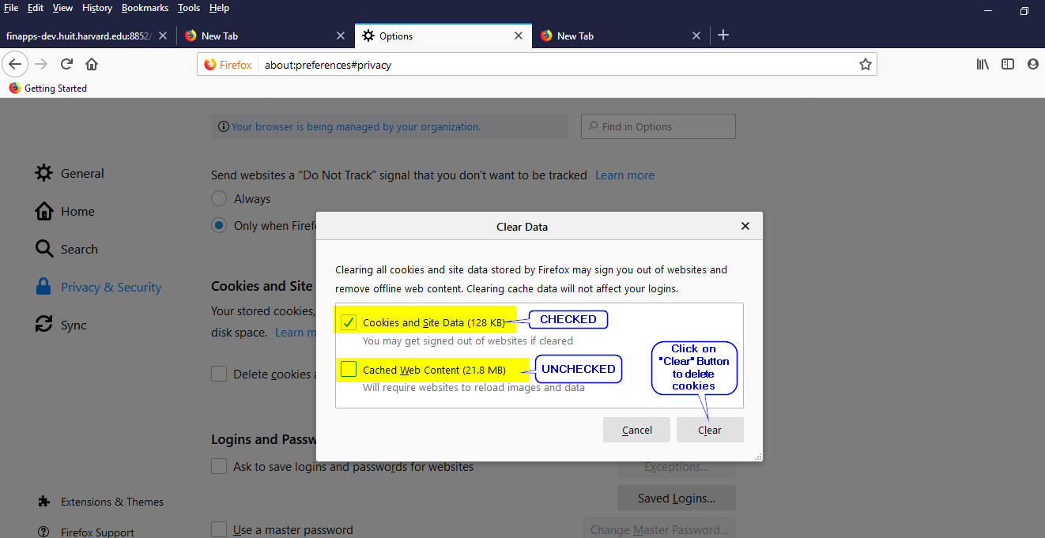

Screen 6: Please click “Clear Now”, cookies will be cleared.
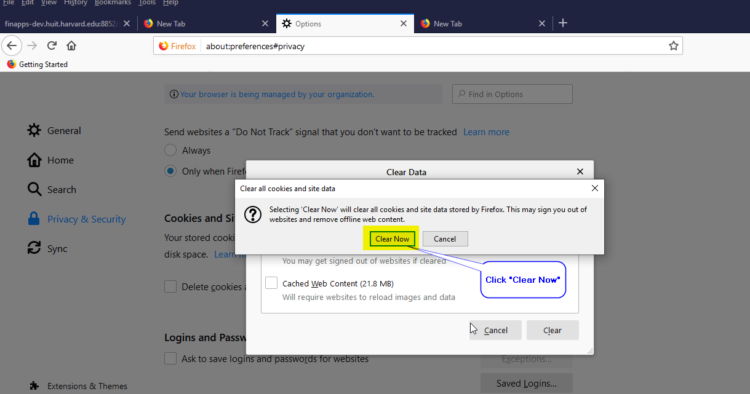
Please close Firefox and re-open it again to login to “Oracle Financials” via Harvard Key.

